Hi!

Here I present my autonomous musical lighting assembly instructions. STM32F103C8T6 microcontroller does all the processing of audio stream. You can change color and dynamical programs via Bluetooth using your smartphone and/or using hardware buttons. You are welcome to download needed software for Android from the [Google Play Store](https://play.google.com/store/apps/details?id=ru.juraspb.cmu.bluetoothchat&hl=ru).

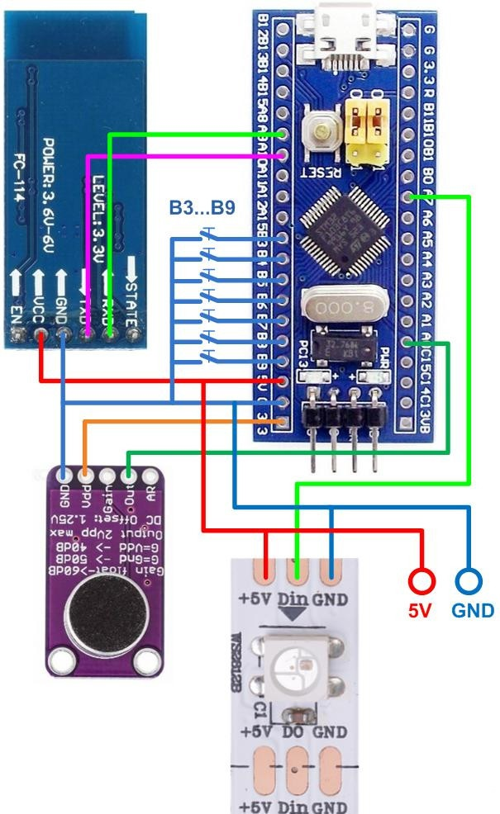

**Wiring diagram**

You will need:

1. [STM32 mini board  
   [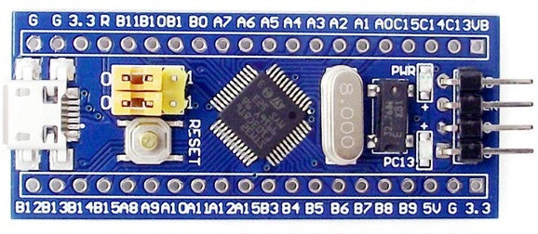](http://shopeasy.by/cashback/view/pdsksg4m6wzm5yxq5dphrkkkfzbjtb4u/?to=https://ru.aliexpress.com/item/mini-Stm32f103c8t6-system-board-stm32-learning-development-board/1609750475.html?spm=a2g0v.search0104.3.14.6e876a961BjLRJ&ws_ab_test=searchweb0_0,searchweb201602_5_10152_10065_10709_10151_10344_10068_5722815_10342_10343_10340_10341_5722915_10543_5711416_10697_5722615_10696_10084_10083_10618_10307_10710_10301_5722715_5711215_10059_10212_308_100031_10103_441_5711515_10624_10623_10622_5711315_5722515_10621_10620_10125,searchweb201603_25,ppcSwitch_5&algo_expid=6e63fbc8-a06d-48f8-8c5c-59aea7cc7c61-5&algo_pvid=6e63fbc8-a06d-48f8-8c5c-59aea7cc7c61&priceBeautifyAB=0)](http://shopeasy.by/cashback/view/pdsksg4m6wzm5yxq5dphrkkkfzbjtb4u/?to=https%3A%2F%2Fru.aliexpress.com%2Fitem%2Fmini-Stm32f103c8t6-system-board-stm32-learning-development-board%2F1609750475.html%3Fspm%3Da2g0v.search0104.3.14.6e876a961BjLRJ%26ws_ab_test%3Dsearchweb0_0%252Csearchweb201602_5_10152_10065_10709_10151_10344_10068_5722815_10342_10343_10340_10341_5722915_10543_5711416_10697_5722615_10696_10084_10083_10618_10307_10710_10301_5722715_5711215_10059_10212_308_100031_10103_441_5711515_10624_10623_10622_5711315_5722515_10621_10620_10125%252Csearchweb201603_25%252CppcSwitch_5%26algo_expid%3D6e63fbc8-a06d-48f8-8c5c-59aea7cc7c61-5%26algo_pvid%3D6e63fbc8-a06d-48f8-8c5c-59aea7cc7c61%26priceBeautifyAB%3D0)
2. [Bluetooth module  
   [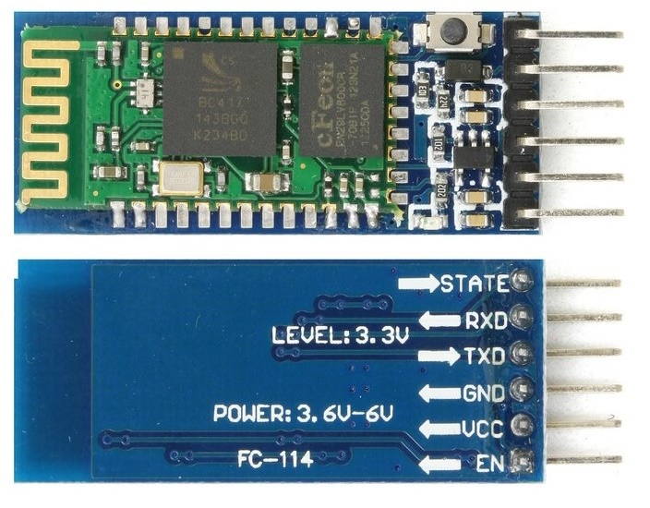](http://shopeasy.by/cashback/view/pdsksg4m6wzm5yxq5dphrkkkfzbjtb4u/?to=https://ru.aliexpress.com/item/Free-shipping-HC05-HC-05-master-slave-6pin-JY-MCU-anti-reverse-integrated-Bluetooth-serial-pass/1898730792.html?spm=a2g0v.search0104.3.1.78021bf37tDW1j&ws_ab_test=searchweb0_0,searchweb201602_5_10152_10151_10065_10344_10068_5724113_10342_10343_10340_10341_10696_5724013_10084_10083_5723513_10618_5724313_10307_10301_5724213_5724413_10059_100031_5724813_10103_5725013_10624_10623_10622_10621_10620_5724913,searchweb201603_6,ppcSwitch_5&algo_expid=b5fda374-5bbc-4368-b1e5-884afac396f0-0&algo_pvid=b5fda374-5bbc-4368-b1e5-884afac396f0&priceBeautifyAB=0)](http://shopeasy.by/cashback/view/pdsksg4m6wzm5yxq5dphrkkkfzbjtb4u/?to=https%3A%2F%2Fru.aliexpress.com%2Fitem%2FFree-shipping-HC05-HC-05-master-slave-6pin-JY-MCU-anti-reverse-integrated-Bluetooth-serial-pass%2F1898730792.html%3Fspm%3Da2g0v.search0104.3.1.78021bf37tDW1j%26ws_ab_test%3Dsearchweb0_0%2Csearchweb201602_5_10152_10151_10065_10344_10068_5724113_10342_10343_10340_10341_10696_5724013_10084_10083_5723513_10618_5724313_10307_10301_5724213_5724413_10059_100031_5724813_10103_5725013_10624_10623_10622_10621_10620_5724913%2Csearchweb201603_6%2CppcSwitch_5%26algo_expid%3Db5fda374-5bbc-4368-b1e5-884afac396f0-0%26algo_pvid%3Db5fda374-5bbc-4368-b1e5-884afac396f0%26priceBeautifyAB%3D0)
3. [Microphone sensor module  
   [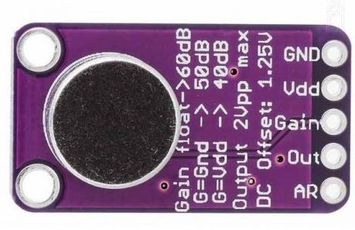](http://shopeasy.by/cashback/view/pdsksg4m6wzm5yxq5dphrkkkfzbjtb4u/?to=https://ru.aliexpress.com/item/-/32674138764.html?spm=a2g0s.8937460.0.0.63d62e0eVm07qX)](http://shopeasy.by/cashback/view/pdsksg4m6wzm5yxq5dphrkkkfzbjtb4u/?to=https%3A%2F%2Fru.aliexpress.com%2Fitem%2F-%2F32674138764.html%3Fspm%3Da2g0s.8937460.0.0.63d62e0eVm07qX)
4. [LED strip](https://ru.aliexpress.com/item/DC5V-WS2812B-1-4-5-30-60-74-96-144-s/32832420003.html?spm=a2g0s.12269583.0.0.3c9b4c800achhZ)  
   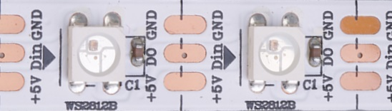
5. Power supply DC 5V min current=(((LEDsnumber*60)/1000)*1.2)A
6. Connectors for strip and power supply. You can take one for connecting to the LED strip from its output end (Dout).

If you do not have a microphone or do not want to use it, you can connect the signal to the controller from the audio output. Use for this simple scheme shown in the figure.

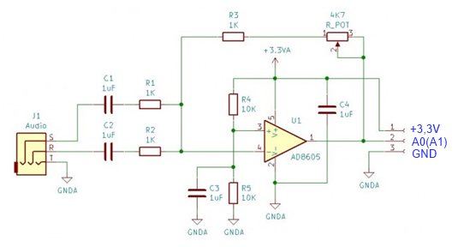

You can also use both options using the inputs **A0** and **A1** of the controller. Use **A15** to select the audio source. If contact A15 is connected to GND, then the program will take the audio signal from input A1, if A15 is left unconnected, then the program will take the audio signal from input A0.

Each circuit has its own pros and cons. For the line input, you will need a cable; on the other hand, microphone captures external sounds. You can use both diagrams.

**FIRMWARE PROGRAMMING**

STM32 programming is done through the USB-ART adapter using the [Flash loader demonstrator](https://www.st.com/en/development-tools/flasher-stm32.html) program. There are several descriptions of the STM32 programming process. You are welcome to choose the description you find clearer.

New firmware for the STM32 microcontroller is always available for download from [Google Drive](https://drive.google.com/open?id=1Hz0A7ePngtKswKY_SBIgg0VM0KC1rL70).

For controlling STM32, you may use the hardware buttons, the terminal program via the built-in micro USB, and the Android application.

**MUSICAL LEDs USER MANUAL**

Software [**MUSICAL LEDs**](https://play.google.com/store/apps/details?id=ru.juraspb.cmu.bluetoothchat&hl=ru) is available for Android on Google Play.

1. **Connection to the controller**

Touch the Bluetooth in the top right corner of the screen of your smartphone. Choose your Bluetooth controller from the list.

|  |  |
| --- | --- |
|  |  |
|  |  |
| Wait for connection. |  |

1. **Selecting program, direction (mode), brightness, motion speed**

Select musical program using buttons in the **Musical** part of the screen, or dynamic program using first two scrolling bars under the **Dynamic** label. Set comfortable brightness, gain, color and motion speed using sliders in the **Settings** part.

|  |  |
| --- | --- |
| **Dynamic programm control** | **Musical program control** |
|  |  |

You can set the motion direction or performance mode for programs without directed LED light motion (not present in all programs so far) both for musical and dynamic programs using the third scrolling bar in the **Dynamic** part of the screen.

1. **Creating your own dynamic programs playlist**

You can create a list of dynamical programs that will be played in rotation. To do this, consistently select dynamic programs, subprograms, directions (modes), and motion speed, adding programs you like to playlist by hitting the **ADD** button. After you are done, save programs by hitting **SAVE**. Max. number of programs in the list is 80.

Further, you can add programs to playlist at any time by hitting **ADD**. Do not forget to save your new playlist by hitting **SAVE**.

To start playing your playlist check the box **LIST**.

To clear playlist hold the **ADD** button for more than 5 sec.

1. **Changing color design**

For simple dynamic programs (from 3 to 29) that change color depending on subprogram (second scroll bar) you can set your own colors.

You have probably noticed that the zero subprogram uses red V and yellow V as the first two colors in all programs.

You can view all colors used in subprograms from terminal using **AT+PC** (print color) command.

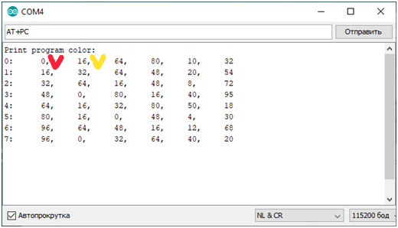

Each line represents the subprogram number (the first character) followed by six color numbers.

Simple dynamic programs use different number of colors from one to six. In the main, colors can be changed for subprograms from zero to six, and seventh subprogram consistently plays subprograms from zero to six.

If the program uses just one color then it is the first color in the line. If the program uses two colors then these are the first two colors in the line, and so on.

Color numbers

|  |  |  |  |  |  |  |  |  |  |  |  |
| --- | --- | --- | --- | --- | --- | --- | --- | --- | --- | --- | --- |
| 0 | … | 16 | ... | 32 | … | 48 | … | 64 | … | 80 | ..95 |
| Red | … | Yellow | … | Green | … | bluish green | … | Dark blue | … | Violet | … |

You can change colors both from terminal and from the Android software.

**Changing colors from the Android software**

1. Set the second scroll bar to a position from zero to six depending on which subprogram colors you want to change.

Program number (0 to 29) can be set to any value. The selected subprogram of the selected program starts playing

2.

2.1. Set static color by the *color* slider. Select the color you want to use first in selected subprogram.

All LEDs light up with selected light.

2.2. Hit the **ADD** button. Color will be added to the selected subprogram.

2.3. Again, set static color you want to use second by the color slider.

All LEDs light up with selected light.

2.4. Hit the **ADD** button. The second color will be added to the selected subprogram...

...repeat actions 2.1 – 2.2 to set colors from third to sixth. It is necessarily to set all six colors.

**Note:** In the static color mode, pressing the ADD button changes to the current static color, the color of the last installed dynamic program (the program that was before the static color was set). The 6 color always changes, shifting the colors of the program to the beginning. For example, entering in a row 6 colors, old colors numbers new letters: **123456, ‘r’-> 23456r, ‘g’->3456rg, ‘b’->456rgb, ‘m’->56rgbm, ‘s’->6rgbms, ‘v’->rgbmsv**, so after entering 6 colors of color **123456**, they will be replaced by **rgbmsv**

Check the color in all programs. If you are satisfied, hit **SAVE** to save color settings.

Have a nice time!

**The following chapters are not needed for ordinary use, but if you want to customize the controller to your liking, the firmware allows you to do this.**

**Changing colors from terminal software**

You can use any terminal program including ARDUINO IDE port monitor.

From terminal software, you can set:

1. Number of LEDs in the strip;

2. Colors of dynamic programs;

3. Brightness level of both musical and dynamical programs;

4. Motion speed;

5. Dynamic programs playlist.

In addition, you are able to save parameters from terminal.

Setting up is done via AT commands. The list of AT commands is constantly growing and is available for specific firmware by AT+H command.

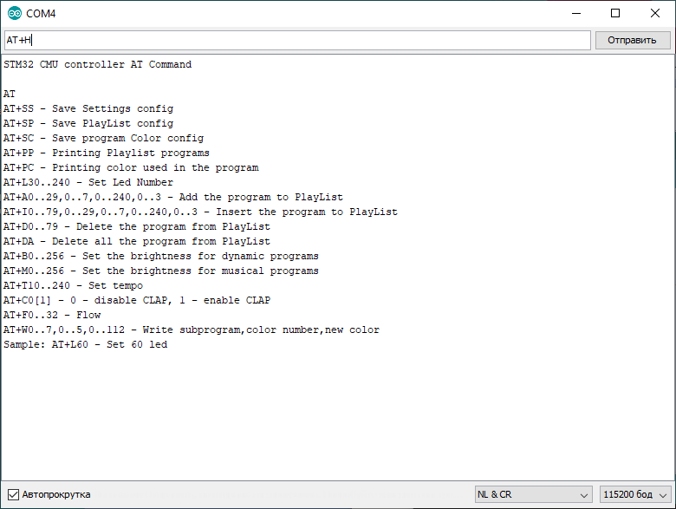

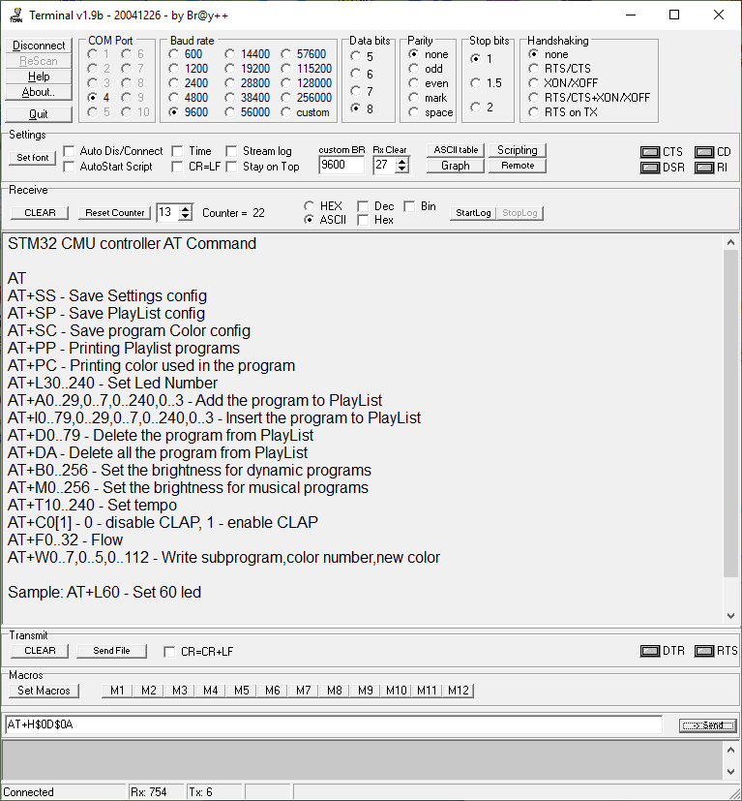

**The main takeaways for color choice**

1. Dynamic programs from third to twenty-ninth (exceptions are present) have seven color subprogram modes each, plus one combinative program. Subprograms are set with the second scroll bar and their numbers are from zero to seven. The seventh one is combinative, and it alternately picks colors of programs from zero to six.
2. Max. number of colors used in dynamic programs from third to twenty-ninth equals six.
3. You can view list of dynamical subprograms using AT+PC command

For example:  
0:  0, 15, 31, 47, 63, 79  
1:  80, 70, 60, 50, 40, 30  
……..  
Thus in all programs from third to twenty-ninth  
by default zero program uses colors 0, 15, 31, 47, 63, 79 (red, yellow … )  
by default first program uses colors 80, 70, 60, 50, 40, 30  
……

1. Colors are as on rainbow: 0-red,…..,16-yellow,….,32-green,….,48-bluish green,….,64-dark blue,….,80-violet,95-red,112-white 100%,…..,128-white 0%(black).

For setting your colors from terminal, select dynamic program that uses all six colors and then select the dynamic program **n**, whose colors you would like to change.

Set the first color typing AT+ W**n**,0,**c1**, where **c1** is the color number from 0 to 128   
Set the second color typing AT+ W**n**,0,**c2**, where **c2** is the color number from 0 to 128 Set the third color typing AT+ W**n**,0,**c1**, where **c1** is the color number from 0 to 128   
…..  
Set the sixth color typing AT+ W**n**,0,**c6**, where **c6** is the color number from 0 to 112

During the set up, colors are changed to yours.

You can also change colors from the Android software.

To do this, select dynamic program that uses all six colors and then select the dynamic program, whose colors you want to change. You will be unable to view the dynamic program playing until the end of the setting.   
1. Set the first static color using slider and hit the **ADD** button.   
2. Repeat these actions for remaining six colors

It is necessary to set up all six colors. After you are done, play your subprogram and make sure that colors you selected are now used. If you like this color solution, **SAVE** it.

**Setting up the hardware buttons (contacts)**

Buttons purpose:  
**B9** – saving all parameters as defaults when turn the power on  
**B8** – setting the number of active LEDs in the strip (discretely)   
**B7** – dynamic program selection;  
**B6** – musical program selection;  
**B5** – turning ON/OFF the dynamic programs changing mode;  
**B4** – setting up the LED strip brightness.  
**B3** – setting up the program speed.